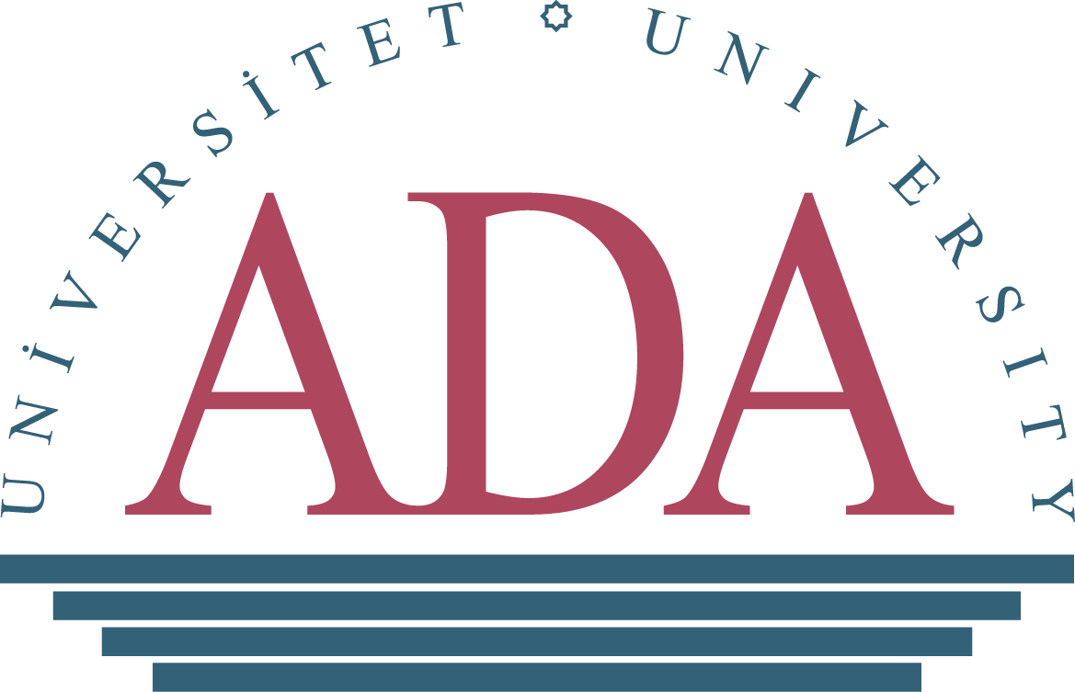
ADA UNIVERSITY EXECUTIVE EDUCATION
CASPIAN BASIN STUDIES PROGRAM
FOR FOREIGN THINK-TANKS
November 13-20, 2021, Baku, Azerbaijan

APPLICANT INFORMATION
Full Name:
 | Last | First

Gender: |  | Date of Birth:
Date Month Year
Citizenship:

Work Phone: | Ext. | Email:

Mobile:

EDUCATION (PLEASE LIST ALL HIGHER EDUCATION INSTITUTIONS ATTENDED)

College/University:

From: |  |  | To: |  | Did you graduate? | YES | NO | Degree:
Other:

From: |  | To: |  | Did you graduate? | YES | NO | Degree:

Other:

From: |  | To: |  | Did you graduate? | YES | NO | Degree:

EMPLOYEMENT INFORMATION
Current Workplace:
Address:

Position and/or Diplomatic Rank (If applicable):

Current Responsibilities:

Years of working experience in the current workplace:

Total years of working experience:

PREVIOUS WORKPLACE (PLEASE LIST PREVIOUS EMPLOYEMENT FOR THE LAST 10 YEARS)
Company/Organization | Job Title: | Dates of employment:

AREAS OF PROFESSIONAL INTEREST/EXPERTISE

AREAS OF PERSONAL INTEREST

MOTIVATION LETTER (MAXIMUM 500 WORDS)
- PLEASE DESCRIBE YOUR INTEREST IN PARTICIPATING IN THE “CASPIAN BASIN STUDIES” PROGRAM. HOW YOU WILL BENEFIT FROM IT AND APPLY THE KNOWLEDGE GAINED IN THE PROGRAM IN YOUR CURRENT WORK?

- WHAT ARE YOUR EXPECTATIONS FROM “CASPIAN BASIN STUDIES” PROGRAM?

DISCLAIMER AND SIGNATURE
By typing my Name and Surname below I certify that my answers are true and complete to the best of my knowledge.

Signature: |  | Date:

* Please, send your current résumé (maximum 2 pages) and passport copy enclosed with the application form to:
Ms. Chinara Mammadli, Administrator, Government Programs, Executive Education, at cmammadli@ada.edu.az, Tel: (+99412) 4373235 ext. 473, or (+99455) 5024692
Application Deadline: October 10, 2021

NB: Incomplete Application Form will not be considered.

